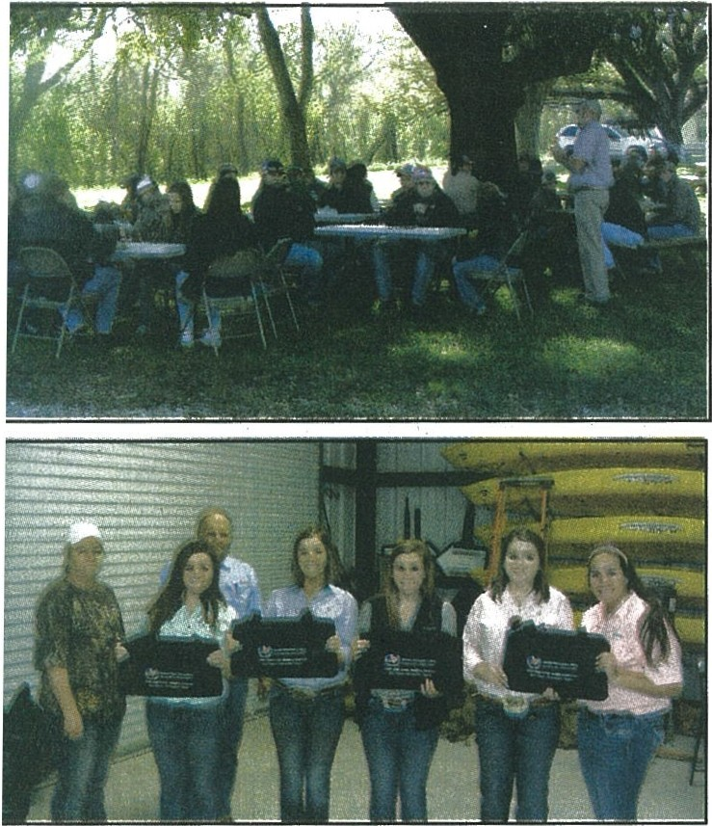
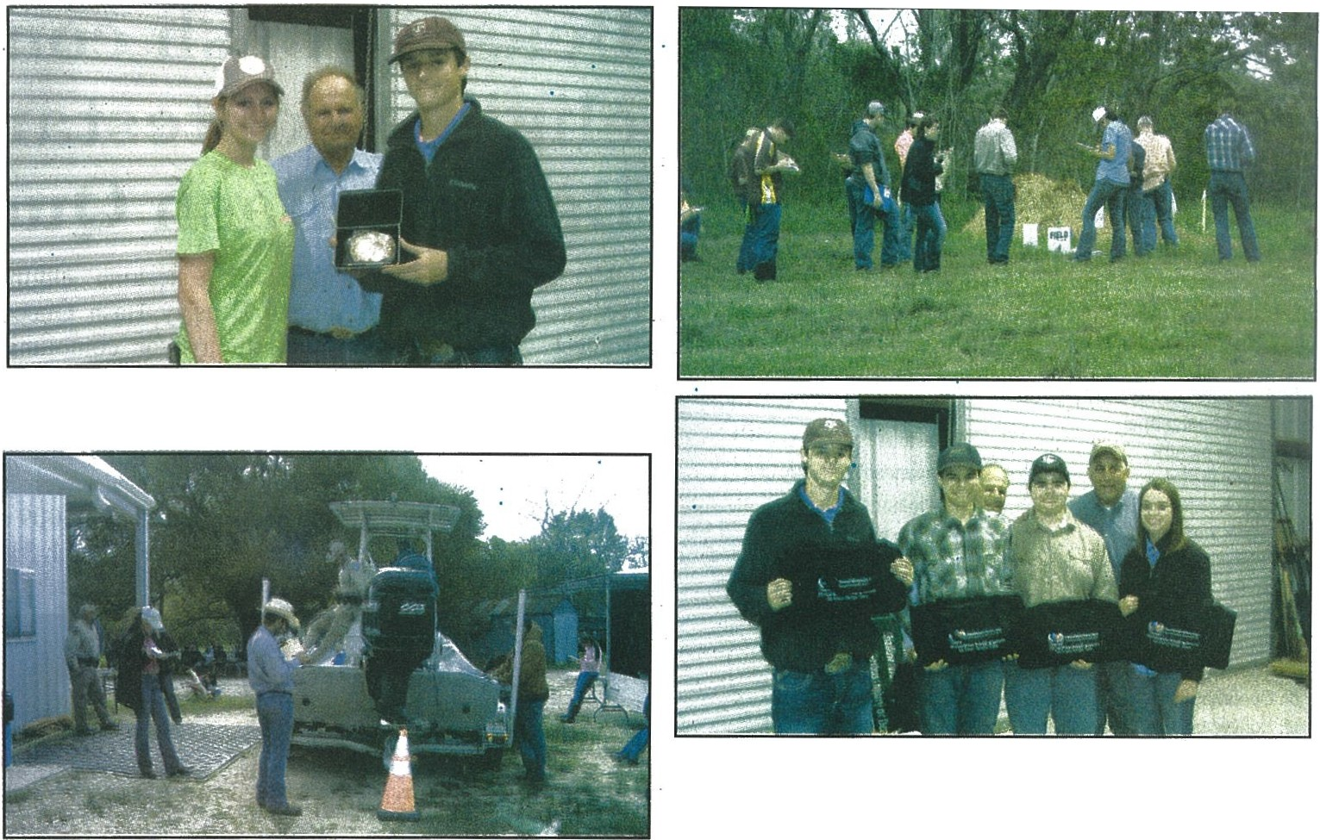
Third place home site team from Cinco Ranch included Maddie Costlow,Karls Torrez, Meagen Sissel, Lexi Neel
High point winners in the Range contest were Conner
Neumann .of Bellville and Molly Koeck f Klein
First place Range team from Bellville consisted of Gabe
Janish, Jordan Horak,
Neumann
abriel Rodriquez and Conner
.
.
and Sarah Roberts .
6th Annual Gulf Coast .Wildlife-RangeLand-Honle Site J·udging Contest
Coastal Plains Soil&Water Brazosport, Weimar, East BBQ along with chips Fort Bend County EXtension . for allowing the .use of their · from their busy schedules Conservation District# 317, · Beard, Tarkington, cypress donated by Frito Lay, were and Agents, .Conservation ranch with facilitis and the to get the students here to was the host ofthe 6thAnnual ·· Lakes,·Klein Collins, Klein enjoyed by all for lunch. District Employees and assistance·they provided for participate. We .woulq · like Gulf Coast Wildlife Judging Oak, Cypress Springs, Coastal Plains SWCD Directors', Rebecca the contest. to wish all of these students Contest, which was held Morton Ranch, Klein ISD, would like to thank all of Brummond- Ag..teacher of · "We also want to thank all and teachers luck at the state on March 22 at Long Acres George Bush, Deer ·Park, the sponsors including; Fort Klein ISD, who was a great of the schools who showed judging contest."
Ranch and Nature Tourism . Cinco Ranch, Cypress Falls, Bend County Farm Bureau, help with the Range Contest their support by allowing .Pictured Above: Scenes Center off of Williams Way and Cypress Ranch. · Cpital Farm Credit, Rudy's an our ·appreciation .also . their students to participate from the 6th annual Guif Blvd. in Richmond, Texas. The students were very Country Store & BBQ, goes out to The Henderson- in our contest and the Ag Coast Wildlife Judging
Co-hosting the contest excited to win belt buckles Frito Lay, The Henderson- Wessendorff Foundation teachers who ·took time Contest
together with Coastal Plains, for the High Point Winner Wessendorff Foundation, =- --·-
was Waters Davis SWCD, of each contes category' and and ·Paul Freund Farms, who Wharton County SWCD, embroidered duffel bags for so generously gave their and Matagorda SWCD. This the top three teams of each support to the contest by year, Coastal Plains extended contest category.Amazingly, their contributions. Coastal the contest to include the there were two High Point . Plains SWCD would also Home Site Judging event. winners in the Range contest like to express appreciation This contest was a huge which had tied scores that to all the agencies who success With over 200 FFA could not be broken. worked so diligently on students participating from . Door prizes consisting of Monday and Tuesday to severalschoolsthroughoutthe Yeti cups and gift cards to make the contest a success. region of the state including; Texas Roadhouse were also These agencies included Bellville, Halletsville, givt'.n out to students and NRCS Soils Dept., NRCS Schulenburg, Flatonia, teachers. Technicians, Engineers, and Cuero, Pearland, Angleton, BBQ sandwiches from District Conservationists, Sweeny, Columbia-Brazoria, Rudy's Country Store and Texas Parks and Wildlife,

